LAB 2 DBMS

1.Update the damage amount to 25000 for the car with a specific reg-num(example ‘K

A053408’) for which the accident report number was 12.

SQL query:

update participated

set damage_amount=25000

where reg_num='KA053408' and report_num=12;

output:

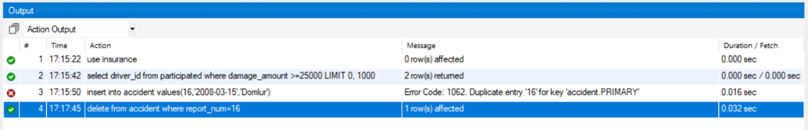

2. Add a new accident to the database.

SQL query:

insert into accident

values(16,'2008-03-15','Domlur');

output:

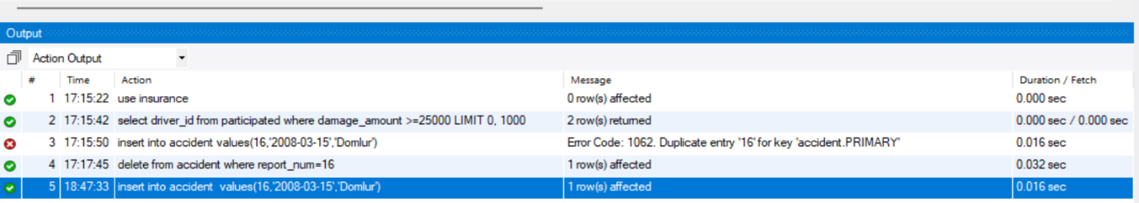

3. Find the number of accidents in which cars belonging to a specific model (example ‘Lancer’) were

involved.

SQL query:

select count(report_num) CNT

from car c, participated p

where c.reg_num=p.reg_num and model="Lancer";

output:

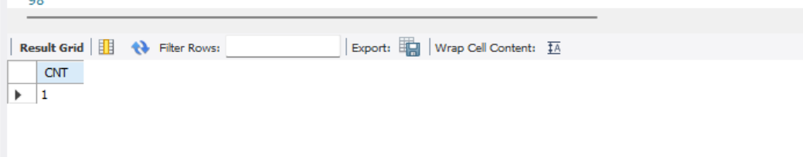

4. Find the total number of people who owned cars that involved in accidents in 2008.

SQL query:

select count(report_num) CNT

from accident

where year(accident_date)="2008";

output:



5. Find the number of accidents in which cars belonging to a specific model (ex: ‘Lancer’) were

involved accidents in 2008.

SQL query:

select count(a.report_num) CNT

from car c, accident a

where year(a.accident_date) ="2008" && c.model="Lancer";

output:



6. LIST THE ENTIRE PARTICIPATED RELATION IN THE DESCENDING ORDER OF DAMAGE AMOUNT.

SQL query:

SELECT * FROM PARTICIPATED

ORDER BY DAMAGE_AMOUNT DESC;

Output:

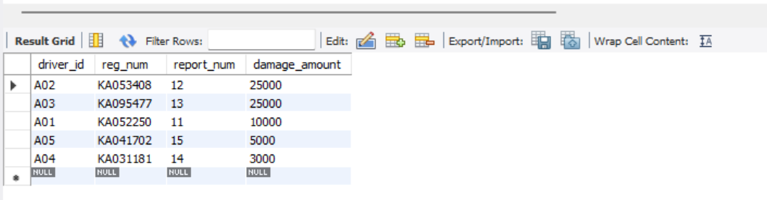

7. FIND THE AVERAGE DAMAGE AMOUNT

SQL query:

SELECT AVG(DAMAGE_AMOUNT)

FROM PARTICIPATED;

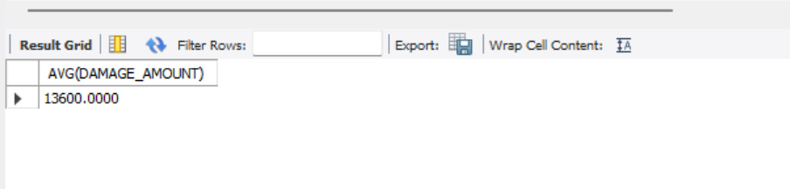

8. DELETE THE TUPLE FROM PARTICIPATED RELATION WHOSE DAMAGE AMOUNT IS BELOW THE AVERAGE DAMAGE AMOUNT

SQL query:

DELETE FROM PARTICIPATED

WHERE DAMAGE_AMOUNT<

( select avg_amt

FROM(SELECT AVG(DAMAGE_AMOUNT) as avg_amt FROM PARTICIPATED) as tmp);

Output:



9. LIST THE NAME OF DRIVERS WHOSE DAMAGE IS GREATER THAN THE AVERAGE DAMAGE AMOUNT.

SQL query:

SELECT NAME FROM PERSON A, PARTICIPATED B WHERE A.DRIVER_ID = B.DRIVER_ID

AND DAMAGE_AMOUNT>(SELECT AVG(DAMAGE_AMOUNT) FROM PARTICIPATED);

Output:

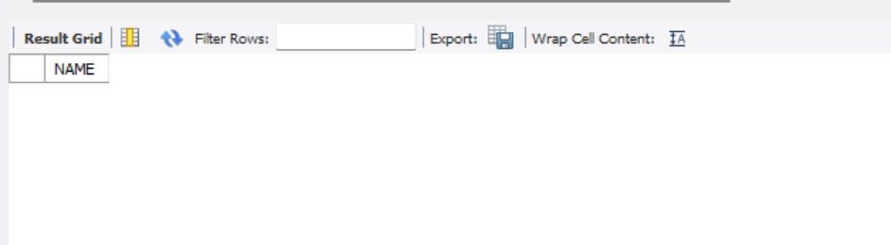

10. FIND MAXIMUM DAMAGE AMOUNT.

SQL query:

SELECT MAX(DAMAGE_AMOUNT) FROM PARTICIPATED;

Output: